**Experiment: Differential Amplifier**

**Aim:**

To implement a differential amplifier of gain 10 and analyze its transient characteristics.

**Tool Used:**

LTspice

**Theory:**

Differential amplifiers apply gain not to one input signal but to the difference between two input signals. This means that a differential amplifier naturally eliminates noise or interference that is present in both input signals.

For a Level 3 NMOS, PMOS let’s assume

VT = 0.4V

VDD = 1.8V

Kn = 120µA/V2 ,

Kp = 120µA/V2 ,

Which implies

r01 = 1/ lambdan*ID

r02 = 1/ lambdap*ID

Which gives the value of Rout to be 16.66Kohm

Which gives a value of (W/L) = 30 for 100uA ID.

Hence with this value of W/L we get a VGS of 0.635V

**Circuit Schematic:**

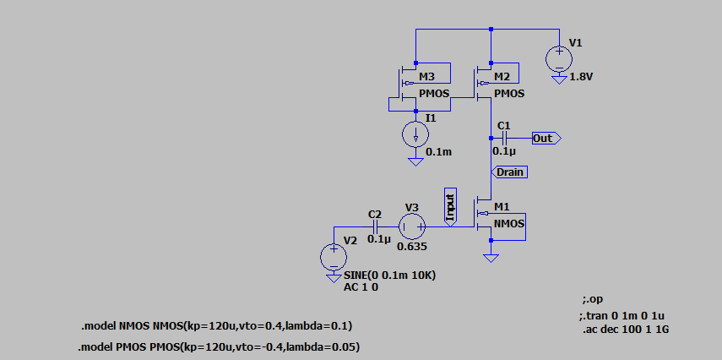

**Output Waveforms:**

**--- Operating Point ---**

**V(n001): 1.8 voltage**

**V(n002): 0.15892 voltage**

**V(drain): 0.218448 voltage**

**V(out): 2.18448e-008 voltage**

**V(input): 0.635 voltage**

**V(n003): 0 voltage**

**V(n004): 0 voltage**

**Id(M1): 9.97249e-005 device_current**

**Ig(M1): 0 device_current**

**Ib(M1): -2.28446e-013 device_current**

**Is(M1): -9.97249e-005 device_current**

**Id(M3): 0.0001 device_current**

**Ig(M3): -0 device_current**

**Ib(M3): 1.65108e-012 device_current**

**Is(M3): -0.0001 device_current**

**Id(M2): 9.97249e-005 device_current**

**Ig(M2): -0 device_current**

**Ib(M2): 1.59155e-012 device_current**

**Is(M2): -9.97249e-005 device_current**

**I(C2): 0 device_current**

**I(C1): -2.18448e-020 device_current**

**I(I1): 0.0001 device_current**

**I(V3): 0 device_current**

**I(V2): 0 device_current**

**I(V1): -0.000199725 device_current**

Transient characteristics

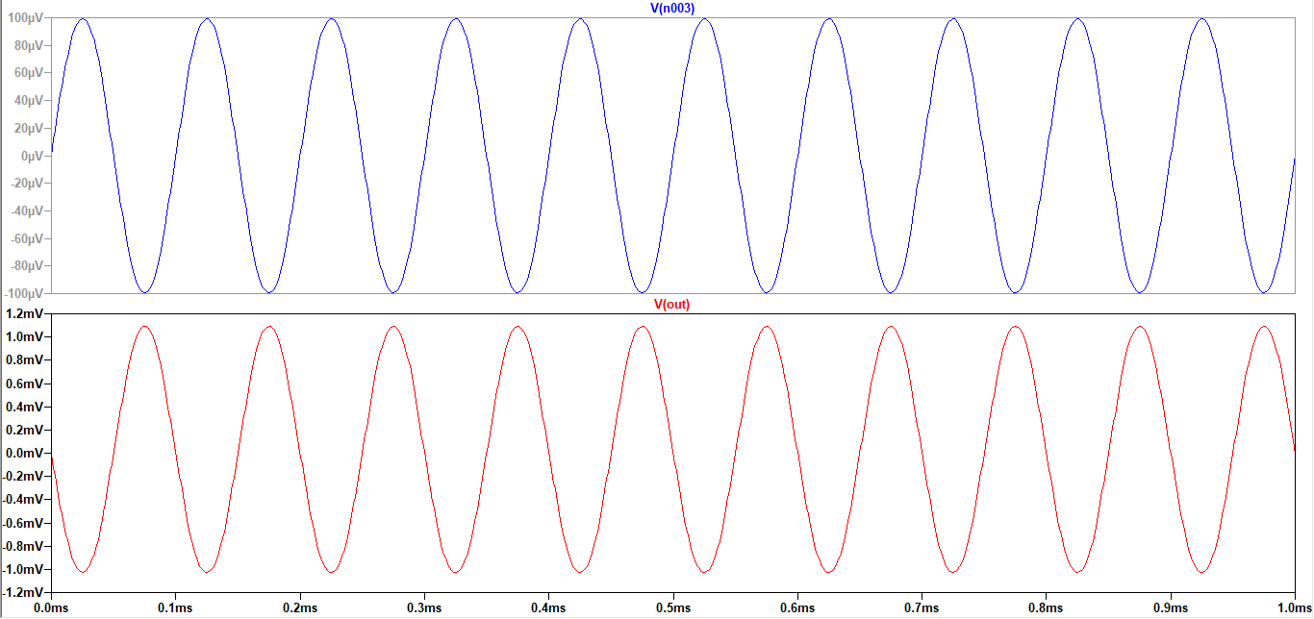

**Result:**

The circuit is designed for a gain of 10 and the output is verified to be correct.